Name: _____________________ #: _______

Graph Assessment

Directions: Write the correct letter of the statement that best matches the reference source.

1. ________ bar graph A. graph used to show change over time

2. ________ pictograph B. graph used to compare information using bars

3. ________ line graph C. graph used to compare information using pictures

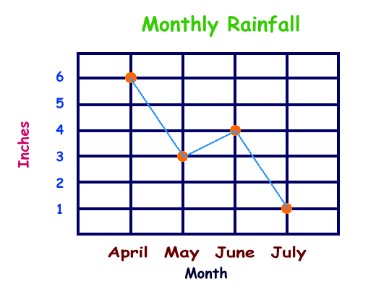
Directions: Reach each question and choose the best answer.
Students’ Favorite Fruit

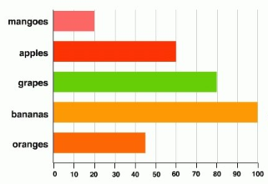

Types of Fruit

Number of Students

4. According to the bar graph, which combination of fruits would equal 105 students?
A. mangoes and apples
B. bananas and mangoes
C. oranges and grapes
D. apples and oranges

5. According to the bar graph, how many total students were given the survey?
A. 300
B. 305
C. 310
D. 315

6. A student is writing a report on recycling. The student learns that different kinds of material are recycled in different amounts. What type of graph should she use to best display this data?
A. bar graph
B. line graph
C. pictograph
7. Based on the line graph, which two months had a total of 10 inches of rain?
A. July and April
B. May and June
C. April and June
D. April and May

8. Based on the line graph, what is the total amount of rain that fell April to July?
A. 14 inches
B. 10 inches
C. 13 inches
D. 4 inches

9. A boy placed four leaves in a caterpillar’s cage. He observed the number of leaves that remained in the caterpillar’s cage each day. What type of graph should be use to best display this data?
A. bar graph
B. line graph
C. pictograph

Directions: Using the information in the chart to create a graph. Be sure to include all parts of the graph.

10. – 15.
_____________________

Colors | Amount of Paint (gallons)
Red | 20
Orange | 13
Yellow | 18
Green | 5
Blue | 10

16. – 21.
_____________________
Plant Growth
Day | Height (cm)
0 | 0
5 | 2
10 | 4
15 | 6
20 | 8

