7th Grade Unit 1 Study Guide
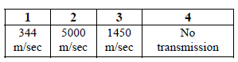
- Which speed represents a gas?
- What increases as pitch increases?
- Sound travels fastest through a solid, liquid or gas?
- Why can’t you hear sound in space?
- What is the primary source of the energy released by the Sun?
- The Sun provides heat and light for the Earth. What produces these forms of energy on the sun?
- What causes a seismic wave?
- During an earthquake what causes the damage to the buildings?
- How does energy from the sun heat the Earth’s atmosphere?
- What kind of wave does this represent?
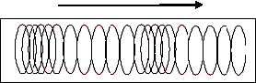

- Write an example of an electromagnetic radiation?

- 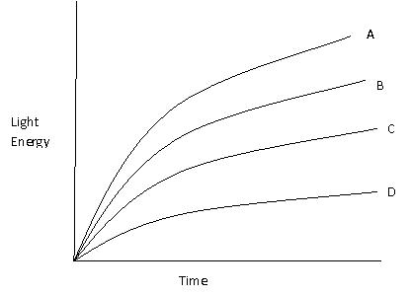
This graph represents 4 different interior colors of cars. Which interior will get the hottest when left in the sun? Why?
- Why does a black shirt make a person warm as opposed to a white shirt on a sunny day?
- Define wavelength.
- Describe the amplitude of a wave with a soft, high-pitched sound?
- A single seismograph can determine how far away an earthquake has occurred but not exactly where. Explain, with the aid of a diagram, why it is necessary to obtain information from three different seismograph sites to locate the epicenter of an earthquake.

