6th Grade Study Guide Unit 1
- 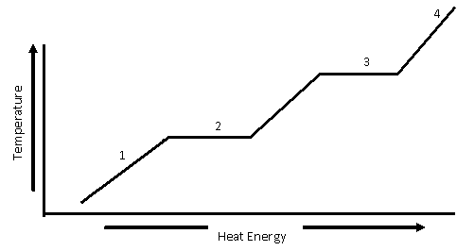
Label what is happening in #2 ______________________________________________________
- Label what is happening in #3 ________________________________________________
- What is kinetic energy_______________________________________________________
- What is potential energy ______________________________________________________

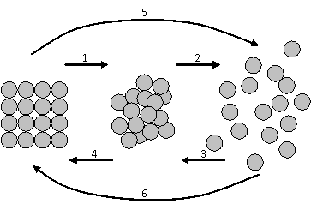
What is happening at #1?
What is happening at #2?
What is happening at #3?

- Draw a picture of conduction.
- Draw a picture of convection.

- Draw a picture of radiation.

- When does a rubber band have the most potential energy?
10 . Explain what is happening at each number.

11. Explain what is happening at each number.
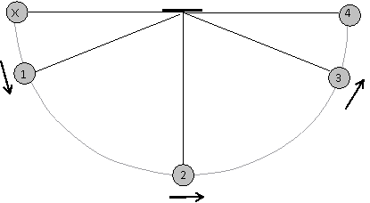

12.What is happening in this container of water?
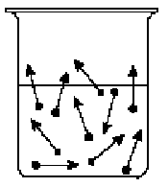
13. Which graph represents evaporation?
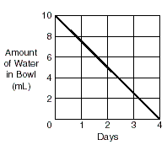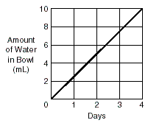

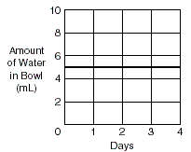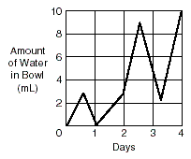

14.Why does rubbing alcohol evaporate when it is on your skin?
15. What is the difference between the way molecules move in a conductor and an insulator?
16. Write an example of potential energy.
17. Write an example of kinetic energy.
18. Using 3 different types of balls how does a student find out experimentally which ball has the most energy?
19. Draw 15 atoms of silver in a closed system before AND after the silver has melted.

